|  |  |  |  |
| --- | --- | --- | --- |
| **F:\Learning bugs\Foundation Subjects\Dolly the Fly - Science.jpgLyng Primary School Knowledge Organiser** | | | |
| **Topic: Rocks and soils** | **What’s beneath our feet?** | **Year 3** | **Spring 1** |

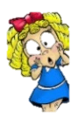

|  |  |
| --- | --- |
| **What Step On and Goldilocks words will I use?** | |
| **Spelling** | **Definition** |
| **bedrock** | Bedrock is the solid rock in the ground which supports all the soil above it. |
| **fossil** | A fossil is the hard remains of a prehistoric animal or plant that are found inside a rock. |
| **geology** | Geology is the study of the Earth's structure, surface, and origins. |
| **igneous rock** | In geology, igneous rocks are rocks that were once so hot that they were liquid. |
| **lava** | Lava is the very hot liquid rock that comes out of a volcano. |
| **magma** | Magma is molten rock that is formed in very hot conditions inside the earth. |
| **metamorphic rock** | Metamorphic rocks are rocks that have had their original structure changed by pressure and heat. |
| **Palaeontology** | The branch of science concerned with fossil animals and plants. |
| **sediment** | Sediment is solid material that settles at the bottom of a liquid. |
| **sedimentary rock** | Sedimentary rocks are formed from sediment left by water, ice, or wind. |
| **soil** | Soil is a mixture of tiny particles of rock, dead plants and animals, air and water. |
| **subsoil** | The subsoil is a layer of earth that is just below the surface soil but above hard rock. |
| **topsoil** | Topsoil is the layer of soil nearest the surface of the ground. |

**Notable scientists**

**Mary Anning**

**(1799 –1847)**

A**n English fossil collector, dealer, and palaeontologist.**

|  |
| --- |
| **What should I already know?** |
| * I have identified and named a variety of everyday materials including wood, plastic glass, metal, water and rock. * I have described the simple physical properties of a variety of everyday materials. * I have compared and grouped a variety of everyday materials on the basis of their simple physical properties. * I have identified and compare the suitability of a variety of everyday materials, including wood, metal, plastic, glass, brick, rock, paper and cardboard for particular uses. * I have found out how the shapes of solid objects made from some materials can be changed by squashing, bending, twisting and stretching. |

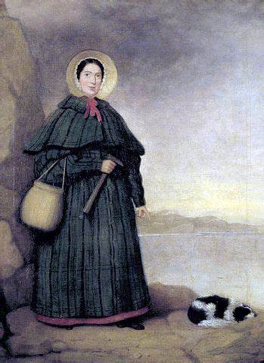

|  |
| --- |
| **Investigate!** |
| * Compare and group together different kinds of rocks on the basis of their simple, physical properties. * To recognise that soils are made from rocks and organic matter * To identify the different types of rocks around school (igneous, metamorphic and sedimentary) * Describe in simple terms how fossils are formed when things that have lived are trapped within sedimentary rock. |



**What will I know by the end of the unit?**

|  |  |  |
| --- | --- | --- |
| **Rocks**  **There are three types of naturally occurring rocks:** | **Soil** | **Fossils** |
| **Sedimentary Rocks** | |  | | --- | | **Our Enquiry Questions** | | * What are the different properties of rocks? * What are the physical properties of rocks? * How are fossils formed? * What can palaeontologists learn from fossils? * How are different soils formed? * What are the layers of sedimentation in soil? | | Fossils are the remains of prehistoric life. They are usually formed when a living thing (plant or animal) dies and the body is covered up or buried by sediment over tens of thousands of  years. Some fossils are formed when the tough  bones and teeth in animals, and the woody part of plants are preserved.  Other fossils are made from imprints in surrounding sedimentary rock such as footprints or imprints from shells. Fossils tell us about the Earth and about life that existed hundreds of thousands and millions of years ago |
| Sometimes, little pieces of rocks that have been weathered can be found at the bottom of lakes, seas and rivers This is called sediment. Over millions of years, layers of this sediment builds up forming sedimentary rocks. Examples include limestone and chalk. Sedimentary rocks are porous and can easily be worn down . |
| **Igneous Rocks** |
| When molten magma cools, igneous rocks are formed. This either cools and forms rocks under the earth’s surface, or flows out of erupting volcanoes as lava and may mix with other minerals. Examples include granite and basalt.  This type of rock is strong, hardwearing. |
| **Metamorphic Rocks** |
| When some igneous and sedimentary rocks are heated and squeezed (pressured), they form  metamorphic rocks. Examples include slate and marble. Metamorphic rocks are strong. |

**Top soil**

This layer contains rotting organisms and plants is full of nutrients.

**Sub soil**

Tightly packed soil that is light in colour and contains less minerals.

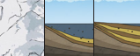

**Rocky soil**

Rocks that are breaking down and becoming soil.

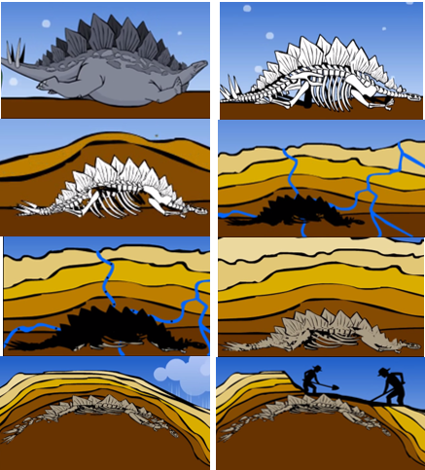

**Bedrock**

This layer is the solid rock in the ground which supports all the soil above it.



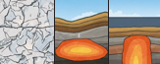

|  |  |  |  |
| --- | --- | --- | --- |
| **F:\Learning bugs\Foundation Subjects\Dolly the Fly - Science.jpgLyng Primary School Knowledge Organiser** | | | |
| **Topic: Rocks and soils** | **What’s beneath our feet?** | **Year 3** | **Spring 1** |

|  |  |  |  |
| --- | --- | --- | --- |
| 1. What is geology? | **S** | | **E** |
| The study of dinosaurs. |  |  | |
| The study of the rocks that form Earth. |  |  | |
| The study of plants from the Stone Age. |  |  | |

|  |  |  |
| --- | --- | --- |
| 5. What are fossils? | **S** | **E** |
| The remains of prehistoric life. |  |  |
| Bones that are left in soil. |  |  |
| Rocks that are decorated to look like art. |  |  |

|  |
| --- |
| 1. Name the three different types of rocks. |
| START - |
| END - |

|  |  |  |
| --- | --- | --- |
| 6. What are the four layers of soil? | **S** | **E** |
| a) top soil, sub soil, rocky soil and bedrock |  |  |
| b) top soil, lower soil, rocky soil and underneath soil |  |  |
| c) lower soil, under soil, above soil and middle soil |  |  |

|  |
| --- |
| 1. Metamorphic rocks are formed from igneous and sedimentary rocks. |
| START - True False |
| END - True False |

|  |  |  |
| --- | --- | --- |
| 7. Place these in order in which they happen to form a fossil. | **S** | **E** |
| hard parts are turned into fossils over tens of thousands of years |  |  |
| an animal dies |  |  |
| hard parts were buried by sediment |  |  |
| the soft parts decayed |  |  |

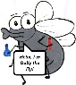

START –

END -

|  |  |  |
| --- | --- | --- |
| 4. Which of these is not a natural forming rock? | **S** | **E** |
| Sedimentary |  |  |
| Concrete |  |  |
| Igneous |  |  |